

# Third-Party Assessment

## Date:

# Risk Summary

{insert summary statement of the risks/observations}

Vendor has an acceptable level of security maturity.

Vendor has demonstrated commitment to the security of their services.  
  
Strong track record of transparency and maintaining the security of their product/service and their own supply chain.

Overall the risk is {low}, and the impact of a vendor comprormise is {high} due to {classification & volume of records}

Based on the review of responses to the security questionnaire, and the review of provided documentation, there is reasonable assurance around <team name> having satisfactory information security controls.

## Risk Finding Count

| Risk Rating | Count |
| --- | --- |
| Significant | 0 |
| Major | 0 |
| Moderate | 0 |
| Minor | 0 |

# Project Overview

## Engagement Scope

**In Scope**

This TPA covers the following:

* General security governance assessment of (insert team name’s) security maturity;
* Focused assessment on the security controls and mechanisms that the vendor has in place, to protect customer and corporate data.

Control Standards Alignment

| **Control Group** | **Control Effectiveness** |
| --- | --- |
| Application Development | Effective |
| Asset Management & Configuration Management | Effective |
| Boundary Defence | Effective |
| Cyber Resilience | Effective |
| Data & Information Protection | Effective |
| Education and Awareness | Not Relevant |
| Endpoint Security & Malware Defences | Not Relevant |
| Identity & Access Management | Effective |
| Incident & Problem Management | Effective |
| IT Change Management | Effective |
| Network & Wireless Security | Not Relevant |
| Platform & Cloud Security | Effective |
| Security Operations & Vulnerability Management | Effective |
| Service Design & Technology Resilience | Effective |
| Physical Security | Effective |
| Third Party Management | Effective |
| Security Governance | Effective |

# Risk Assessment

| Security Domain | | Observation & Recommendation |
| --- | --- | --- |
| Application Development | | No gaps observed |
| Asset Management & Configuration Management | | No gaps observed |
| Cyber Resilience | | No gaps observed |
| Data & Information Protection | | No gaps observed |
| Education and Awareness | | No gaps observed |
| Endpoint Security & Malware Defences | | No gaps observed |
| Identity & Access Management | | No gaps observed |
| Incident & Problem Management | | No gaps observed |
| IT Change Management | | No gaps observed |
| Network & Wireless Security | | No gaps observed |
| Platform & Cloud Security | | No gaps observed |
| Security Operations & Vulnerability Management | | No gaps observed |
| Service Design & Technology Resilience | | No gaps observed |
| Physical Security | | No gaps observed |
| Third Party Management | | No gaps observed |
| Security Governance | | No gaps observed |

## Risk Rating[1]

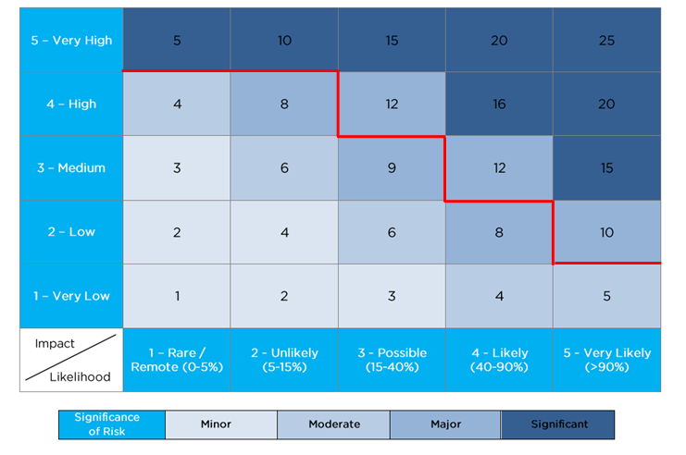

# Key Considerations

Below are the key points discussed while performing the TPA – Some of these were not mentioned in the scoping documents but understood will be incorporated during the delivery/implementation.

* {insert any assumptions or considerations identified during the BO interviews}
* Risks are assessed based on Bupa’s Risk Management framework.
* All risks identified are based on Residual Risk which is the risk position that remains if the project doesn’t implement the recommended mitigating / compensating controls outlined in this document.
* The full scope of the Bupa IS Schedule will apply to any MSA entered into with the vendor.

# Document Revision

| Date | Version | Author | Comments |
| --- | --- | --- | --- |
|  | V0.1 | Theodore Savvidis | First Draft |
|  | V0.2 |  | Peer review |
|  | V1.0 | Theodore Savvidis | Final |

1.